**Year 12 ATAR Biology Applecross SHS**

**Genetics test**

Section one: Multiple Choice (20 marks)

Mark your answers with a cross (X) on the answer grid provided at the front of the answer booklet.

Recommended working time: 20 minutes

____________________________________________________________________________

1. The basic unit of inheritance is called a
2. Zygote
3. Chromosome
4. DNA
5. gene
6. If a gorilla has 22 pairs of chromosomes in a skin cell, how many chromosomes are there in the gorilla’s sperm?
7. 11 chromosomes
8. 11 pairs of chromosomes
9. 22 chromosomes
10. 22 pairs of chromosomes
11. When individuals, both heterozygous for a single gene character are crossed, all the offspring happen to resemble their parents for that character. This genetic trait is referred to as
12. Genotypic
13. Dominance
14. Phenotypic
15. Recessiveness
16. Which of the following statements is the best description of a gene?
17. A gene is the total DNA complement of an individual.
18. A gene is a sequence of nucleotides that codes for a specific protein.
19. A gene is a protein molecule which occurs within chromosomes.
20. A gene is the smallest unit of structure within a chromosome.
21. Which of the following statements about the process of meiosis is true?

(a) Meiosis will produce two haploid cells that are identical to the original cell.

(b) Meiosis will produce four haploid cells that show variation to the original cell.

(c) Meiosis will produce four diploid cells that are identical to each other.

(d) Meiosis will produce four diploid cells that are different to each other.

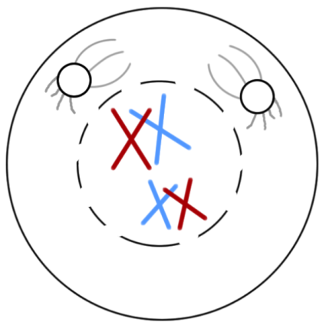Questions 6 and 7 refer to the diagram presented below. It illustrates a cell undergoing cell division.

1. The event represented in this diagram is necessary to

(a) ensure chromosomes separate evenly.

(b) double chromosome number.

(c) ensure that genes are copied accurately.

(d) increase genetic variation.

1. Which of the following is an accurate description of what will happen immediately after this event?
2. Each chromosome pair must replicate.
3. The cell will split into two distinct cells.
4. The spindle fibres will contract and homologous pairs will separate.
5. New genes will be created.
6. A man who carries a sex-linked gene on his X chromosome will pass this characteristic to
7. all his sons
8. all his daughters
9. half his sons
10. half his daughters
11. Blue eyes are recessive to brown eyes. If a blue eyed person (bb) is crossed with a brown eyed person (BB) what percentage of the children will probably have brown eyes?
12. 25%
13. 50%
14. 75%
15. 100%
16. Cystic fibrosis is an autosomal recessive disease. A married couple are both carriers of the disease. If they have two children, what is the probability that both the children will be unable to pass on the disease.
17. 9/16
18. 1/16
19. 2/3
20. 6/8
21. Which of the following best illustrates the generalisation that “the phenotype is the product of interactions between the genotype and the environment’.
22. When butterflies are exposed to high energy radiation some of their offspring have wings with colour patterns not seen in the parents.
23. Males of the African swallowtail butterfly, *Papilo daranus*, are similar wherever the species is found, but the females are variable, often resembling local butterfly species that are distasteful to birds.
24. Specimens of the British race of butterfly, *Aglais urticae*, if they are placed in a warm incubator as pupae, resemble the race of this species found on a Mediterranean island.
25. Specimens of the Australian butterfly, *Tisiphone abeona*, bred in South Australian Laboratories from mating Queensland males and Victorian females, resemble those found naturally around Port Macquarie in New South Wales.
26. The diagram below shows a cell with two pairs of chromosomes and two identifiable genetic regions.

A

a

B

b

Which of the following is a true statement?

1. The chromosome carrying **A** and **a** are homologous because they carry the same genes.
2. **A** and **a** are not alleles because they represent different proteins.
3. The chromosome carrying **A** and **B** are homologous but those carrying **a** and **b** are not.
4. The chromosome carrying A and a are homologous because they code for different traits.
5. A family has 7 sons. The theoretical probability that the eighth child will be a daughter is
6. 1 in 7
7. 1 in 2
8. 1in 8
9. 7 in 8
10. A co-dominant genetic condition is one in which:
11. the heterozygote shows the effect of two different alleles.
12. there are two possible ways to combine alleles.
13. the homozygote has inherited different alleles from each parent.
14. one allele completely hides the effect of another allele.
15. Albinism is inherited as an autosomal recessive trait. If a person has albinism and is married to a person who is heterozygous for the trait:
16. there is a 50% chance of having a child with albinism.
17. there is a 25% chance of having a child with albinism.
18. there is a 75% chance of having a child with albinism.
19. there is a 0% chance of having a child with albinism.
20. A Father’s blood group is O and he has a child with the same blood type. The mother’s blood type could be
21. A or B
22. AB
23. O only
24. A, B or O
25. If a male parent has the alleles TT and a female parent has the alleles Tt:
26. all the offspring will be TT.
27. some offspring will be tt.
28. some sperm will have t alleles.
29. some eggs will have T alleles.
30. Epigenetics involves changes in:
31. DNA
32. an organisms genotype
33. an organisms phenotype
34. separation of chromosomes

Questions 19 and 20 and based on the information contained in the pedigree below.

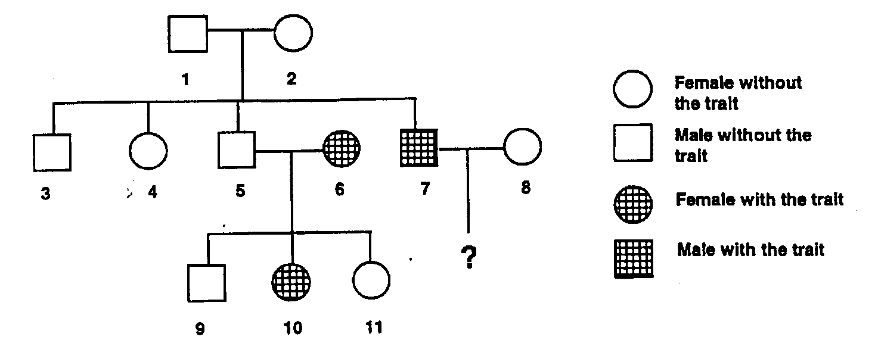

A gene controlling a particular trait occurs in the forms F (dominant) and f (recessive).

1. Which of the following describes the genotypes of the individuals numbered 1 and 2?

(a) **FF** and **ff**.

(b) **Ff** and **Ff**.

(c) **ff** and **ff**.

(d) **Ff** and **ff**.

1. If the individuals numbered 5 and 6 produce one more offspring, which of the following is a correct statement?

(a) The probability of it being a male without the trait is 0.75.

(b) The probability of it being a male with the trait is 0.5.

(c) The probability of it being a male with the trait is 0.25.

(d) The probability of it being a female with the trait is 1.0.

**Applecross Senior High School**

**Year 12 ATAR Biology**

RESULT

**Task 2: Genetics test.**

NAME ______________________________

|  |  |  |
| --- | --- | --- |
| **Section** | **Question type** | **Marks available** |
| One | Multiple choice | 20 |
| Two | Short answer | 30 |
| TOTAL MARKS AVAILABLE | | 50 |

**Section one: Multiple choice (20 marks)**

Mark your answers with a cross (X) on the answer grid provided.

Recommended working time: 20 minutes

|  |  |  |  |  |
| --- | --- | --- | --- | --- |
| Question |  | | | |
| 1 | **A** | **B** | **C** | **D** |
| 2 | **A** | **B** | **C** | **D** |
| 3 | **A** | **B** | **C** | **D** |
| 4 | **A** | **B** | **C** | **D** |
| 5 | **A** | **B** | **C** | **D** |
| 6 | **A** | **B** | **C** | **D** |
| 7 | **A** | **B** | **C** | **D** |
| 8 | **A** | **B** | **C** | **D** |
| 9 | **A** | **B** | **C** | **D** |
| 10 | **A** | **B** | **C** | **D** |
| 11 | **A** | **B** | **C** | **D** |
| 12 | **A** | **B** | **C** | **D** |
| 13 | **A** | **B** | **C** | **D** |
| 14 | **A** | **B** | **C** | **D** |
| 15 | **A** | **B** | **C** | **D** |
| 16 | **A** | **B** | **C** | **D** |
| 17 | **A** | **B** | **C** | **D** |
| 18 | **A** | **B** | **C** | **D** |
| 19 | **A** | **B** | **C** | **D** |
| 20 | **A** | **B** | **C** | **D** |

**Section two: Short Answer (30 marks)**

Write your answers in the space provided.

Recommended working time: 30 minutes

**____________________________________________________________________________**

**Question 16 (6 marks)**

Compare and contrast the following terms:

1. Genotype and Phenotype. (2 marks)

____________________________________________________________________________________________________________________________________________________________________________________________________________________________________

1. Dominant and recessive. (2 marks)

____________________________________________________________________________________________________________________________________________________________________________________________________________________________________

1. The ABO blood group system in humans provides an example of co-dominance. Use this to explain what is meant by the term co-dominance and explain why the ABO blood system is also an example of dominance. (2 marks)

____________________________________________________________________________________________________________________________________________________________________________________________________________________________________

____________________________________________________________________________

____________________________________________________________________________

____________________________________________________________________________

____________________________________________________________________________

____________________________________________________________________________

____________________________________________________________________________

**Question 17 (13 marks)**

Red-green colour blindness is a sex-linked, recessive disorder. Below is information about a family that includes some individuals who are red-green colour blind.

* First generation is a married couple. The female is normal and not a carrier of red-green colour blindness.
* Second generation is the four children from the couple of the first generation. The oldest and second children are both female, the third child is male and the fourth child is male. The older female is married. The remaining three individuals are unmarried. All individuals are normal.
* Third generation is the two children from the couple in the second generation. Both children are male.

Using this information to answer the following questions.

1. Draw a Pedigree chart to represent the information presented above. (1 mark)
2. What is the probability that the females in the second generation are carriers of the red-green colour blind allele? Show a punnet square diagram in your working. (2 marks)

Answer ___________________

1. What is the probability that the males in the third generation are red-green colour blind? Show a punnet square diagram in your working. (2 marks)

Answer _____________________

1. Explain why females are described as being ‘carriers’ of the disease. (2 marks)

____________________________________________________________________________________________________________________________________________________________________________________________________________________________________

____________________________________________________________________________

1. Describe and explain how variation between individuals is achieved through meiosis. (6 marks)

____________________________________________________________________________________________________________________________________________________________________________________________________________________________________

____________________________________________________________________________

____________________________________________________________________________

____________________________________________________________________________

____________________________________________________________________________________________________________________________________________________________________________________________________________________________________

________________________________________________________________________________________________________________________________________________________

**Question 18 (6 marks)**

In andalusian fowl, FB is the gene for black plumage. FW is the gene for white plumage. These genes show incomplete dominance. The heterozygous condition results in blue plumage. Determine the genotype and phenotype ratios expected from the following crosses: (6 marks)

* 1. black X blue
  2. blue X blue
  3. blue X white

**Question 19 (5 marks)**

Sickle cell anaemia is another blood disorder that affects red blood cells, which use a protein called haemoglobin to transport oxygen from the lungs to the rest of the body. Normally, red blood cells are round and flexible so they can travel freely through the narrow blood vessels.

The haemoglobin molecule has two parts: an alpha and a beta subunit. Patients with sickle cell disease have a mutation in a gene on chromosome 11 causing a single amino acid change in the beta subunit of the haemoglobin protein. Describe and explain how this change in the protein could have come about.

________________________________________________________________________________________________________________________________________________________

________________________________________________________________________________________________________________________________________________________

________________________________________________________________________________________________________________________________________________________